Dynamo DB

Step 1: create a table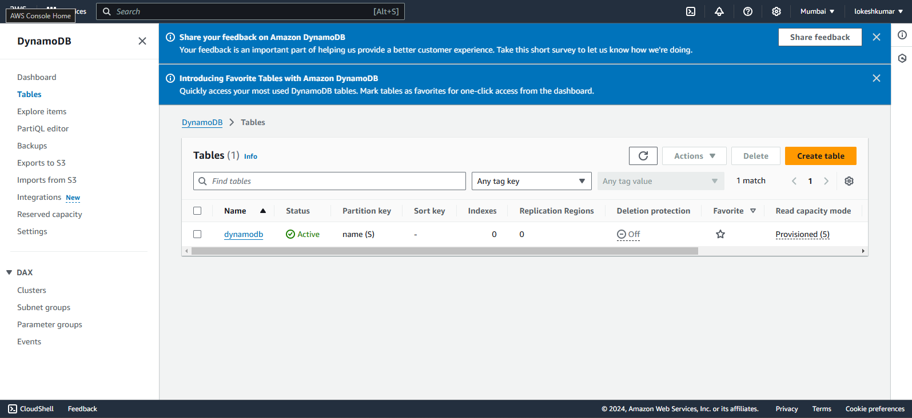

Step 2: create items

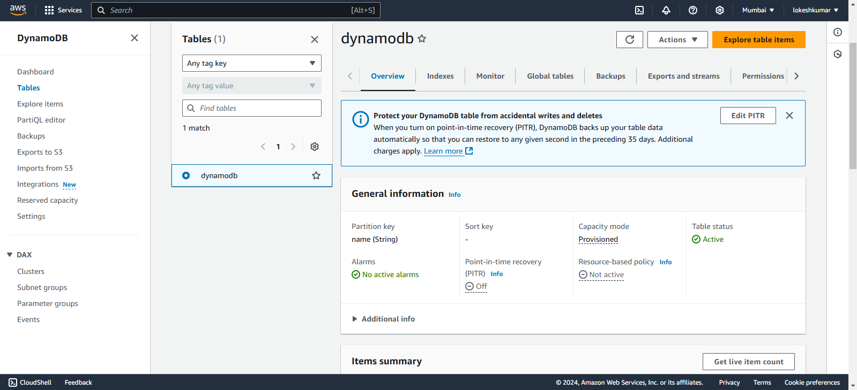

Step 3: create an ec2 instance

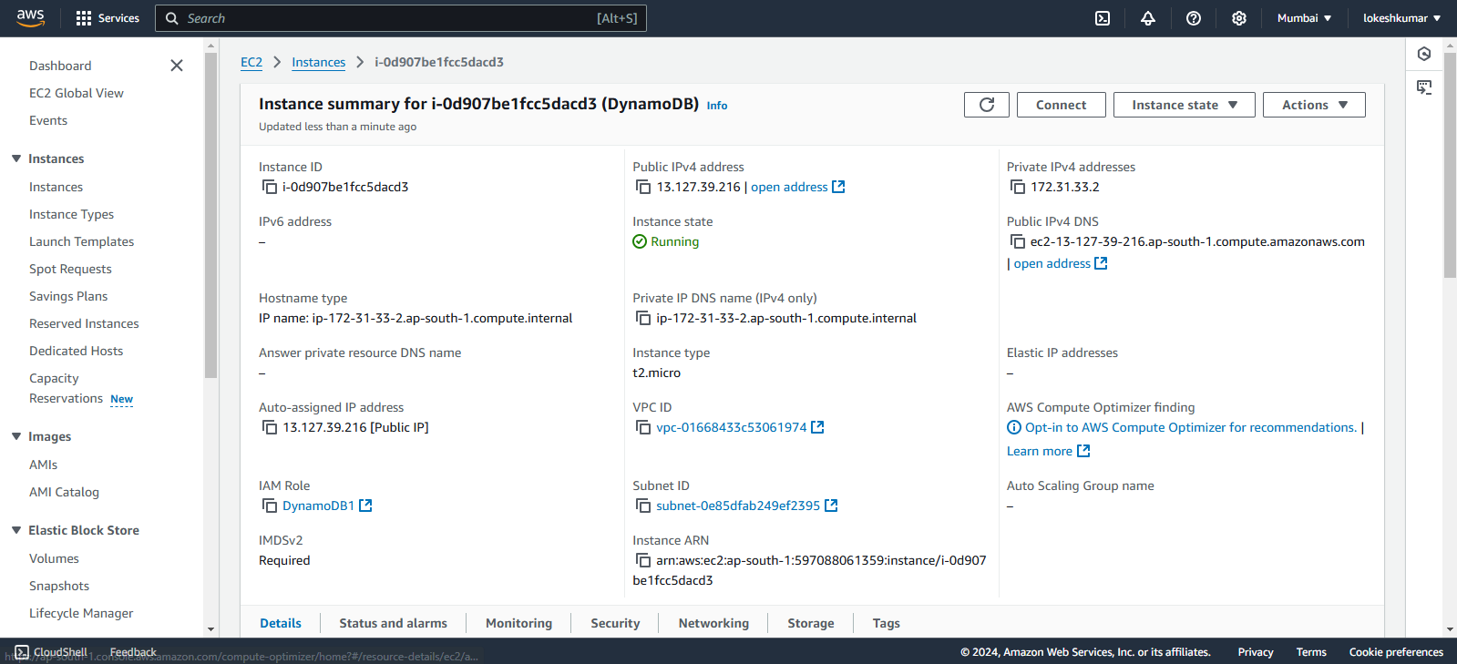

Step 4: create an IAM role and connect “actions>security>modify Iam role”

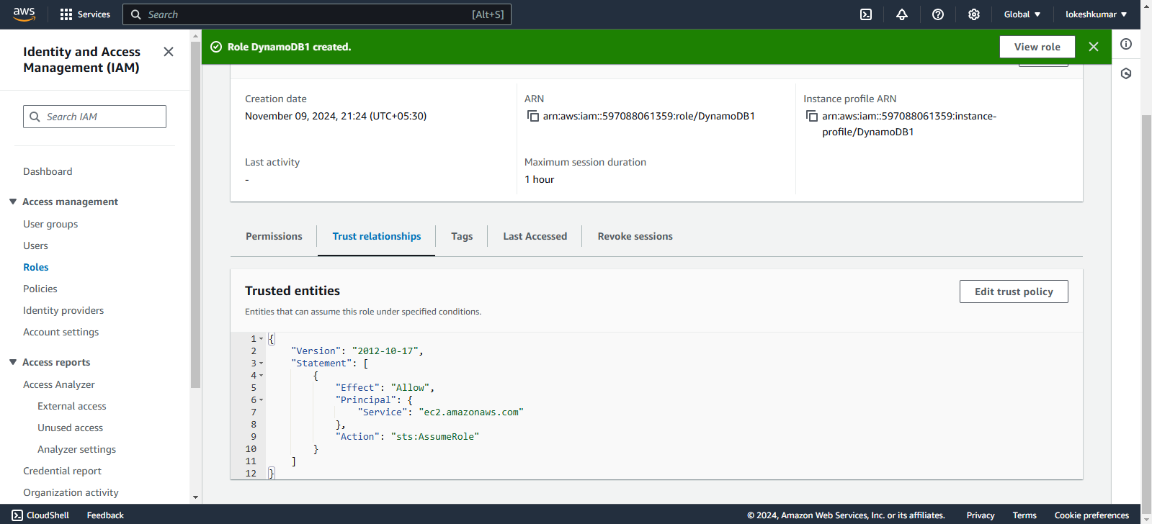

Step 5: Commands

